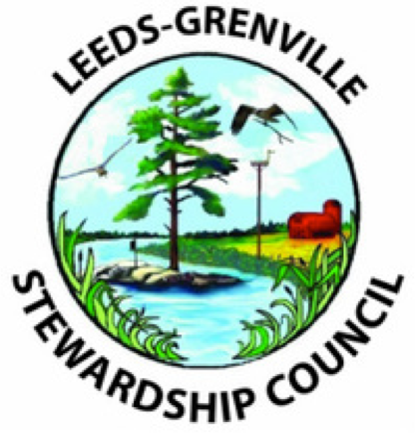

LEEDS GRENVILLE
STEWARDSHIP COUNCIL
2018 Annual Report

Message from the Chair

2018 was another busy year for Leeds Grenville Stewardship! The Council members are a diverse group of volunteers with a joint commitment to environmental stewardship.

Education and Outreach remains a priority, with Wood Working for Wildlife workshops in local schools in the winter and spring being a core program, partnering on the Children’s Water Festival, and supporting tomorrow’s environmental leaders through bursaries. LGSC also contributed to the G7 tree planting with the Frontenac Arch Biosphere Network and maintenance of a butternut grove as a compensation project. Species at Risk continues to be a priority with continued efforts in the recovery of the Gray Ratsnakes in the Frontenac Arch and turtle conservation! Read on to hear about all the details of our efforts in 2018 and see our web site for more information (www.lgstewardship.ca).

We cannot do our stewardship work in the United Counties without the support and encouragement of our many partners. In particular, the United County of Leeds and Grenville and the Rideau Valley Conservation Authority (RVCA) and, provide financial and administrative support, respectively. This has provided an important foundation to support our volunteers and to leverage additional funding for stewardship projects.

We are thankful for all of the many partners who help us to deliver more than any of us could ever achieve on our own. We look forward to their continued friendship and cooperation.

Karen Brown

SUSTAINABLE FORESTS

__________________________________________________

G7 - 2018 National Planting Project – Frontenac Arch Biosphere Reserve

This tree planting initiative was a national effort stemming from the International G7 Summit which was held in June 2018 in the Charlevoix Biosphere Reserve in Quebec. The symbolic planting aimed to:
- raise the community’s awareness of the importance of trees and their functions, and
- promote the local timber industry and the organizations hosting the planting.

The planting at Bateau Channel Park was coordinated by the local Frontenac Biosphere Reserve, and included:
- Students from Gananoque Secondary School
- Township of Leeds and the Thousand Islands
- Friends of Bateau Channel Park

LGSC participated as the “local forestry agent” – determining the species mix, ordering the trees, developing a site plan and coordinating the planting efforts. Special thanks to Martin Streit who helped organize and signed off as the Registered Professional Forester.

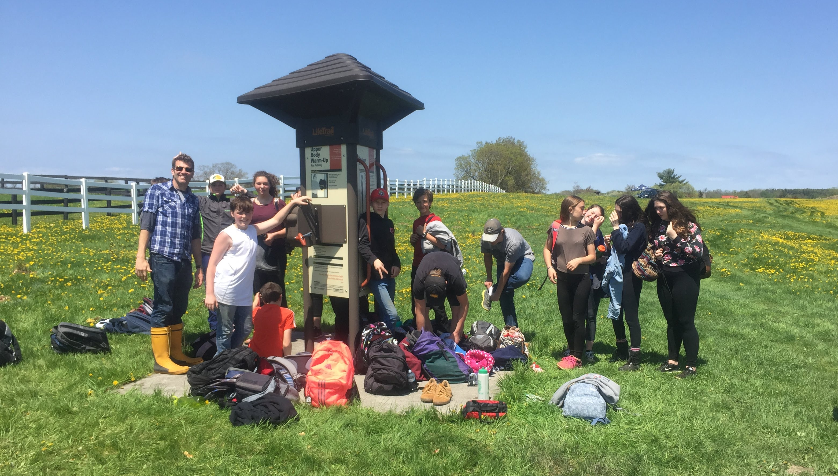

Students receiving instructions

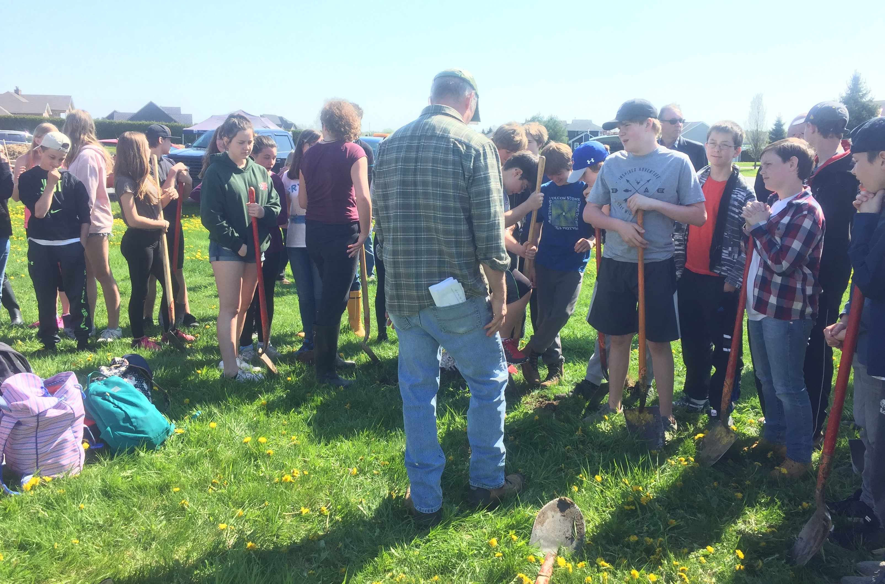

LGSC will do a survival assessment in 2019 and submit a report to the organizing committee at the Charlevoix Biosphere Reserve.

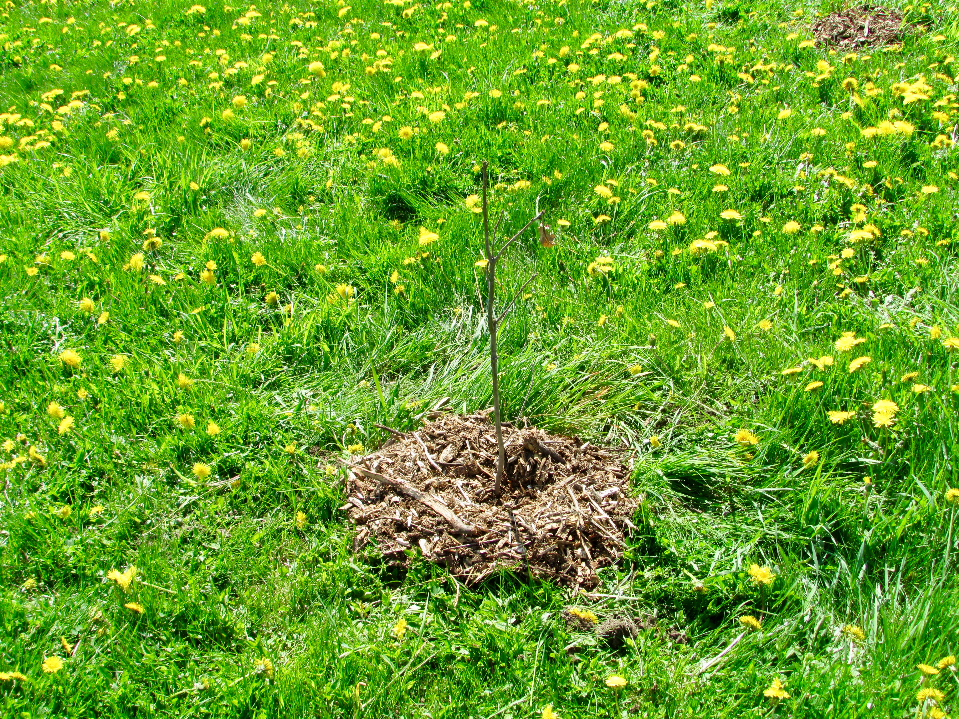

Jowett Refill

LGSC volunteers completed the refill planting on Carl Jowett’s property in Lyn. The survival rate was said to be less than 60% however the hardwoods had lost their leaves at the time of assessment. So, in fact the survival rate was 80%. The additional trees were planted in areas adjacent to or missed the previous year.

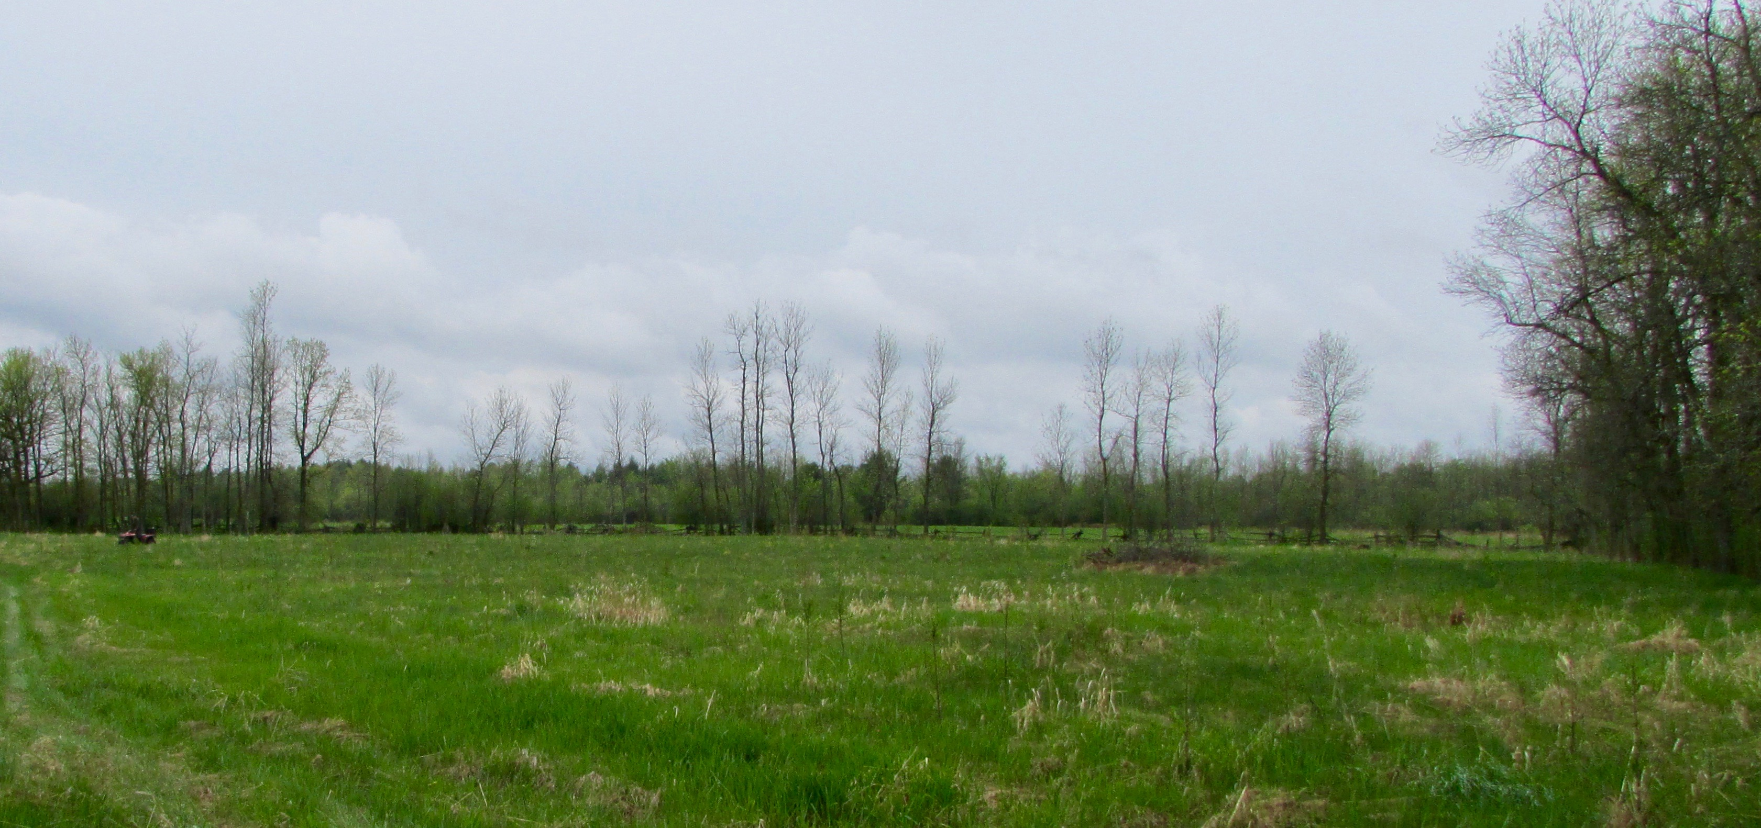

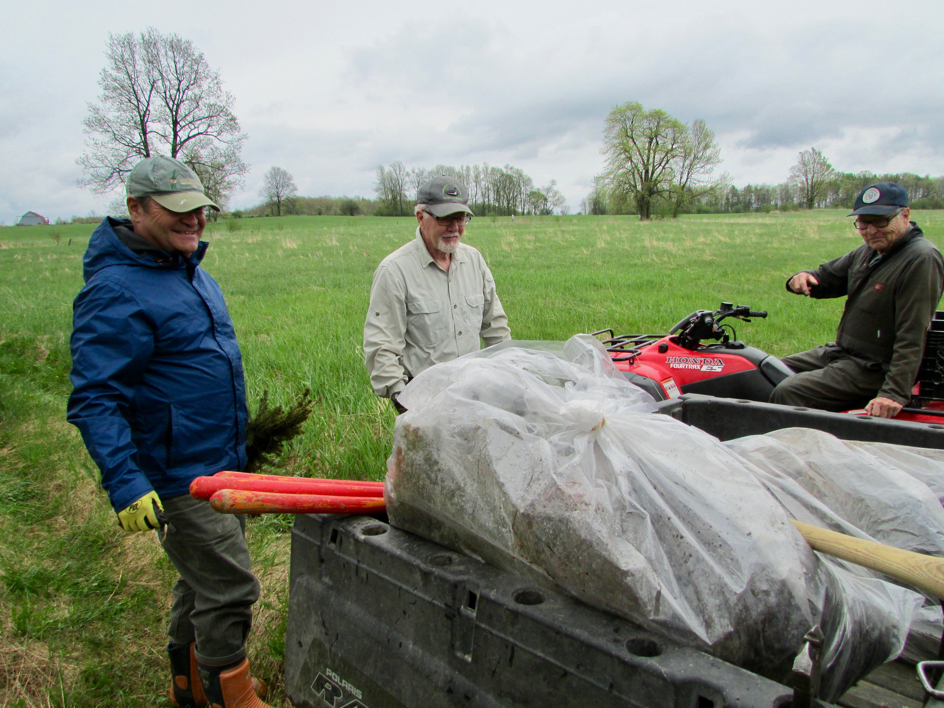

Butternut Recovery Program

LGSC partners with the Rideau Valley Conservation Authority in the delivery of the Butternut Recovery Program. Due to an abundance of seed in 2013, oodles of seedlings and seed were given across Eastern Ontario in spring of 2014. However, there was a severe shortage of Butternut seed in 2014, there were no seedlings given to LGSC in spring of 2015.

As in 2014, the Butternut in 2015, had no volume of seed / nuts. This meant that there were no seedlings to plant in spring in 2016. However in fall 2016, there was sufficient seed for Rideau Valley Conservation Authority to collect and plant.

In 2017 there were Butternut seedlings available for landowners to plant after 2 years absence due to lack of seed. 150 seedlings were given to 12 people in the County of Leeds and Grenville.

The survival rate for our County was 61% based on the information received last fall from 10 of those landowners.

The Butternut in 2017 had little to no seed / nuts available. Therefore, no seedlings were available for distribution by Rideau Valley Conservation Authority in 2018.

Seedlings, although fewer than usual, will be offered in spring of 2019 to those interested and will keep record of survival rate.

Butternut tree range

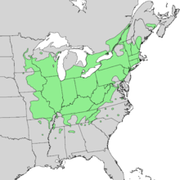

Butternut canker killing this species

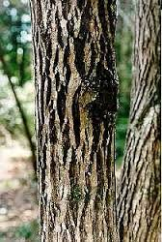

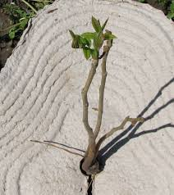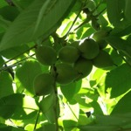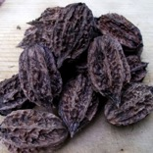

Photos: L to R: Seedling, butternut seeds on a tree, seeds

Butternut Compensation Project

This butternut compensation project came about as a result of a new industry being located in Edwardsburgh Cardinal Township near the Windmill east of Prescott.

In the process of the new industry obtaining an environmental permit, a number of butternut trees were identified, on this property, which would have be removed to permit the construction of buildings and rail lines.

To compensate for the loss of this endangered species the Township agreed to allow a compensation plot on municipal owned land, for not only the trees being removed by this new industry, but extra trees, as needed in the future.

As a result, a butternut health assessment permit was obtained from the Ministry of Natural Resources and a multi-year Memorandum of Understanding developed between The Township of Edwardsburgh Cardinal, South Nation Conservation Authority and Leeds Grenville Stewardship Council for the planting and maintenance of butternut trees at the Blair Road site.

Thirty-nine butternut trees were planted along with forty red oak companion trees in alternating rows spaced three meters apart.

At the official opening in October it was determined that the butternut trees had a 95% survival rate.

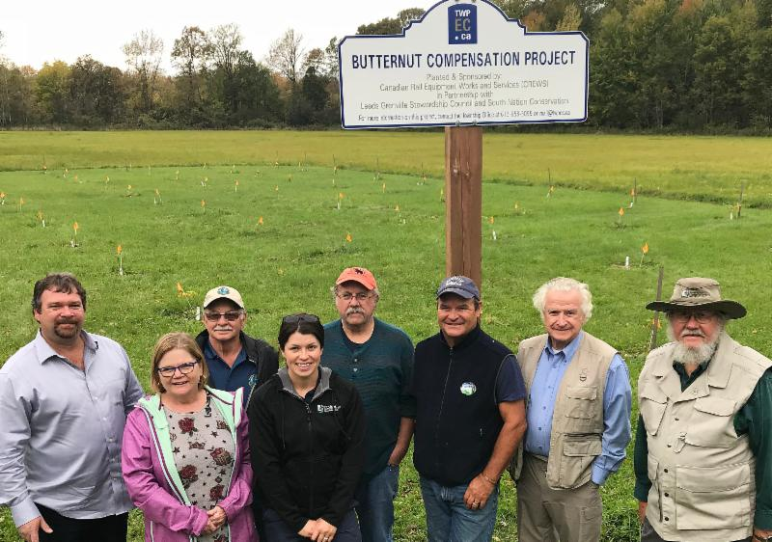

Photo above: Standing in front of the grove are, from left, CREWS owner Clayton Jones, Township CAO/Clerk Deb McKinstry, Leeds-Grenville Stewardship Council's Dave Robertson, South Nation Forestry Technician Cheyene Brunet, Cliff Rogers and Jack Henry (Stewardship Council), Edwardsburgh Cardinal Mayor Pat Sayeau and South Nation representative Lawrence Levere.

2018 was year two of the maintenance of the plot which included mowing watering and maintenance by LGSC. Leeds Grenville Stewardship Council members David Robertson, Cliff Rogers and Jack Henry participated in maintaining the plot during 2018.
The survival at the end of year 2 was 82% (32 alive, 7 dead). The 7 dead trees will be refilled in the spring of 2019 to boost the site back up to 100% as required each year until the end of the 5th growing season.
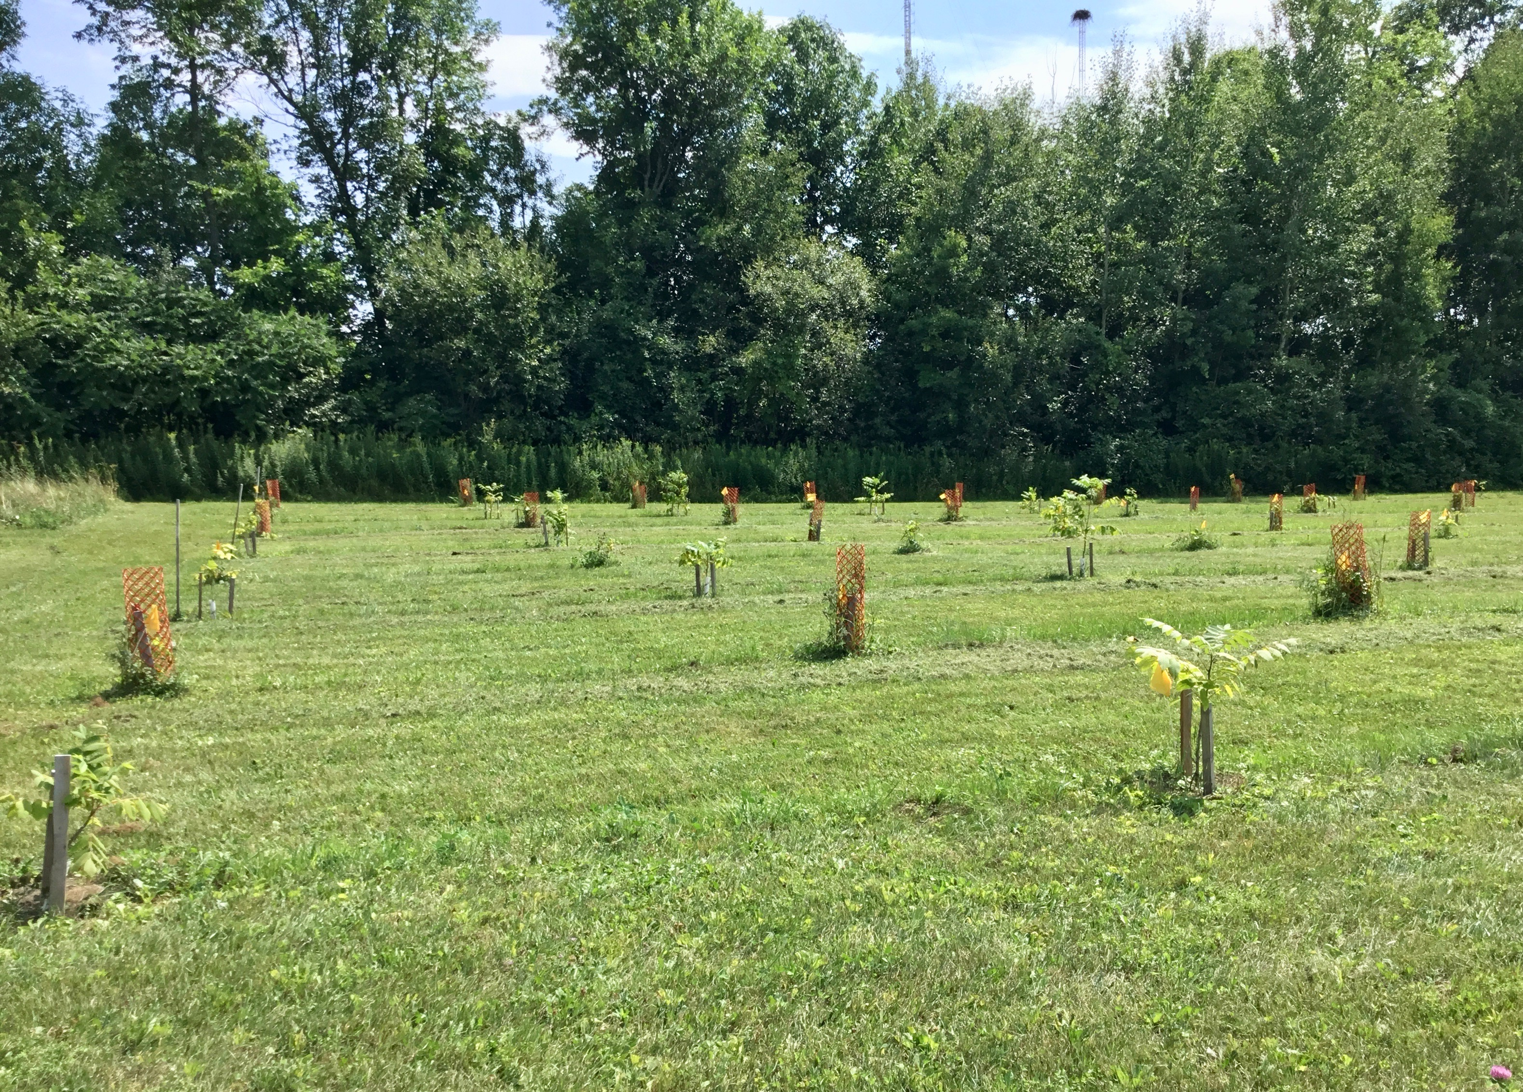

HEALTHY AQUATIC ECOSYSTEMS

Hutton Creek Wetland Complex

The Hutton Creek Wetland is part of a 1445 hectare (3,571 acres) provincially significant wetland complex located in Elizabethtown-Kitley Twp. about 5 km south of the Village of Lombardy. The Rideau Valley Conservation Authority (RVCA) owns the dam at Motts Mills. LGSC has partnered with RVCA and Ducks Unlimited to replace the old dam and restore the wetland’s diversity. The Council members involved in this project include Dwayne Struthers and Shaun Thompson.

In order to facilitate the construction of the new dam, RVCA secured ownership of the entire dam through a combined purchase and large land donation agreement. This also agreement also included ownership of the property immediately downstream from the dam.

After several years of delays construction finally began on replacing the Motts Mills dam in August of 2015. The dam was replaced with an earthen berm water structure. The berm was installed just upstream from the old dam. It is made of rock and clay and has two steel inlet chambers to adjust or hold water levels. Ducks Unlimited, who has vast experience and knowledge in designing and building these structures for wetland purposes, oversaw the construction. The South Kanata Development Corporation voluntarily chose to make a $250,000 contribution to the Rideau Valley Conservation Foundation to jumpstart the dam replacement and wetland restoration.

Since the construction of the old dam in 1952, the Motts Mills Dam has played an important role in maintaining an artificially controlled water level on about 772 hectares of the Hutton Marsh. The provincially significant wetland has been well known in the past as excellent waterfowl habitat as well as important habitat for a diversity of other species. Over time, the amount of open water area in the wetland has diminished along with the diversity of plants, habitat and wildlife. There has been ongoing interest in developing a plan to restore the wetland.

A 3-4 year plan has been developed by RVCA (in consultation with the Advisory committee) for the Hutton Creek Wetland drawdown. In order to develop channels and pools of open water work must first determine: a. what type of work has to be done to create channels and pools of water; b. what type of bottom (rock or clay) exists below the cattails and sediment in the wetland; c. the location of the channels to be developed; and, d. the best location for the pools of water (a clay base is ideal). The research information would also assist in identifying the type of equipment that would be best suited to completing the excavation for the channels and pools (a backhoe, long reach machine, high hoe or a bulldozer).

In 2017 some test holes were dug in the ice and some soil analysis conducted to determine the soil substrate in the wetland and the creek.
The conclusion of this work was the need to dig more test holes to find some better locations to do wetland improvements.

In 2018 more holes were dug to continue the research into where new channels and open water will be developed. This work is being done in partnership and guidance from Ducks Unlimited. RVCA is also investigating some Blanding's turtle opportunities.

Also, in 2018 the partners worked out the details of the first phase of restoration and successfully raised funding for the project to start in 2019.

This first project will be undertaken on property owned by the United Counties of Leeds and Grenville and would be available for multiple use activities by the public, including hunting.

The project is scheduled to be completed December 2019 –March 2020 and will have the following purposes:
a) The creation of three ponds totaling 1.5 acres acting as a quiet area for waterfowl to rear their young and an area for shorebirds to feed.
b) The creation of 500 meters of channels to encourage more habitat and wildlife diversity and providing new fish passages and areas for spawning and feeding as well as creating critical life stage areas for amphibians, turtles and other wildlife.
c) Increasing waterfowl hunting opportunities is a major objective.
d) Promotion of the benefits of the project and feature the many partners by designing and installing interpretive signs on site
e) Involve and engage many local community minded partners including hunters, observers, outdoor enthusiasts and land owners

Dwayne, Shaun and Kerry also conducted a Marsh Monitoring on the Hutton Creek Wetland Complex in the spring of 2017, focusing on amphibians. The program is designed to collect information about the presence and abundance of bird and amphibian species in Great Lakes coastal and inland marshes. It will be interesting to compare the results of the survey to the survey results after the wetland has been fully restored.

New earthen berm just after completion

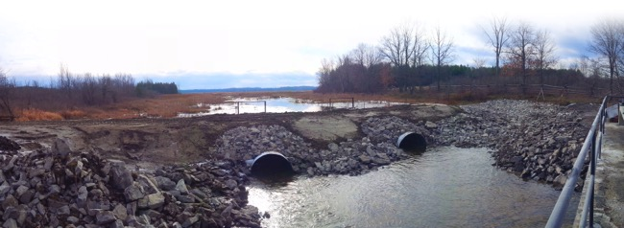

View from Earthen Berm – summer 2016

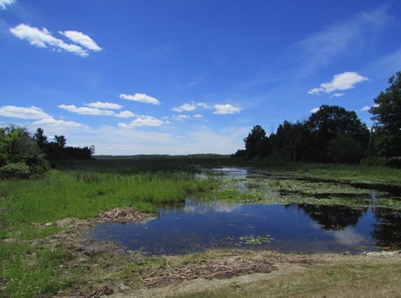

Partnership with Ducks Unlimited to Monitor Marshes

Ducks Unlimited (DU) joined forces with Bird Studies Canada (BSC) to begin monitoring DU marshes on private lands utilizing the Great Lakes Marsh Monitoring Program protocol.

DU also invited LGSC to participate to monitor DU marshes on private lands within the United Counties. Many of these marshes were well known to LGSC folks – two of which are on lands owned by members – so it seemed a natural fit.

The Amphibian Surveys are for:

Green Frog Wood Frog
American Toad Spring Peeper
Northern Leopard Frog Gray Tree frog
Chorus Frog Bull Frog

And the Bird Surveys are for:

American Bittern Least Bittern
American Coot Pied-Billed Grebe
Black Rail Sora
Common Moorhen Virginia Rail
King Rail

Everyone enjoyed a crash course in identifying the calls of the target species and did monitor the following marshes in whole or in part:

1. Dopson - Both frog and bird surveys conducted
2. Elliott – Both frog and bird surveys conducted
3. Struthers -Both frog and bird surveys conducted

4. Motts Mill – Both frog and bird surveys conducted

5. Limerick Forest – Frog surveys conducted

Monitoring at Struthers DU Wetland

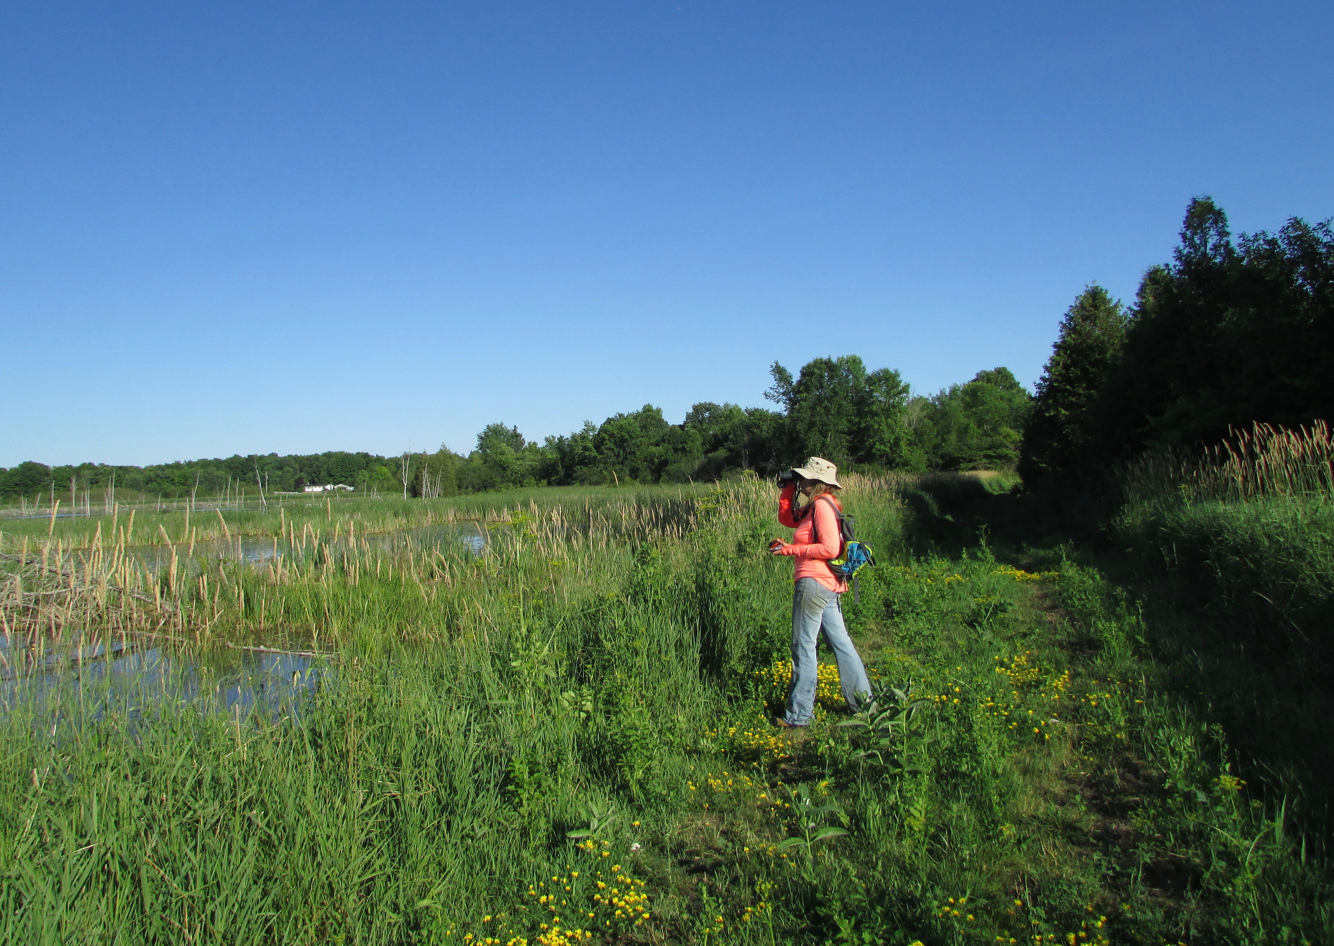

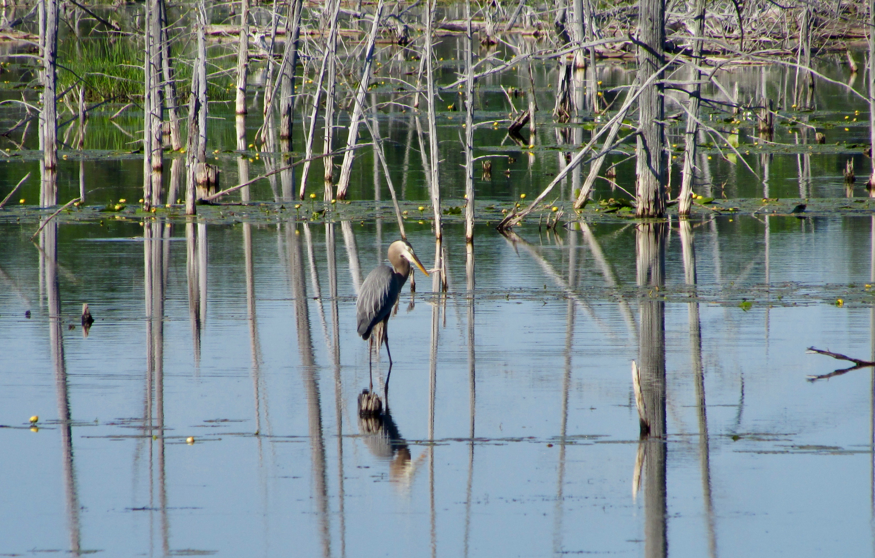

SPECIES AT RISK

Gray Ratsnake

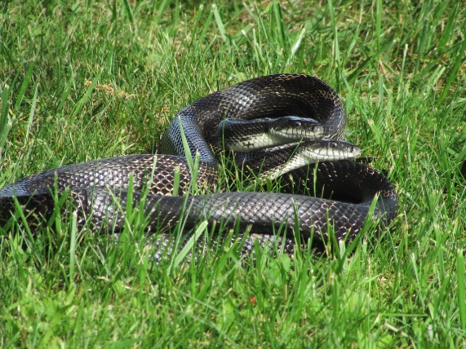
The Gray Ratsnake is listed as threatened on the Ontario Species at Risk list.

In 2005 with funding support from OMNR, Garnet and Dwayne designed and built 12 wood framed, wire mesh nesting boxes to provide protection from egg predators.

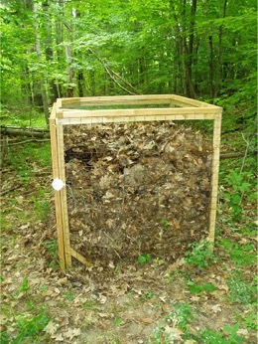

The structures have been deployed throughout the eastern portion of Leeds-Grenville. They are filled annually with a variety of compost substrates designed to maintain a temperature around 30 degrees Celsius, which is necessary for egg incubation. In 2016 a fifth nesting box was added to the landscape and plans are underway to deploy several more.

Since 2009 evidence of over 1250 successful hatchings (egg shells) have been found in the nest boxes that are monitored annually.

- 2005 – year 1 – 9 eggs hatched
- 2009 – 24
- 2010 – 80
- 2011 – 151
- 2013 – 140
- 2014 – 184
- 2015 – 234
- 2016 - 200
- 2017 - 158

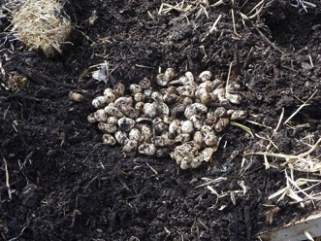

Previous years also helped provide additional information about the little-known phenomenon of parasitism on Gray Ratsnake eggs from the larvae of the postulated carrion beetle. At one location where, nesting boxes have been successful, evidence on some of the eggs showed that they had been destroyed by the beetle larvae which emerge and predate upon the incubating eggs. This site is known to be used communally by gravid Ratsnakes and one belief is that these communally used sites can be more susceptible to this parasitoid.

Traditionally, the nest box sites were monitored by LGSC in the late fall but it was determined from previous years of monitoring that on several occasions we were finding eggs that were yet to hatch or juveniles were just emerging. It was determined that this could risk the successful emergence of juvenile snakes and the timing for nest box monitoring would be done in the spring in the future as not to disturb emerging snakes or alter incubating eggs.

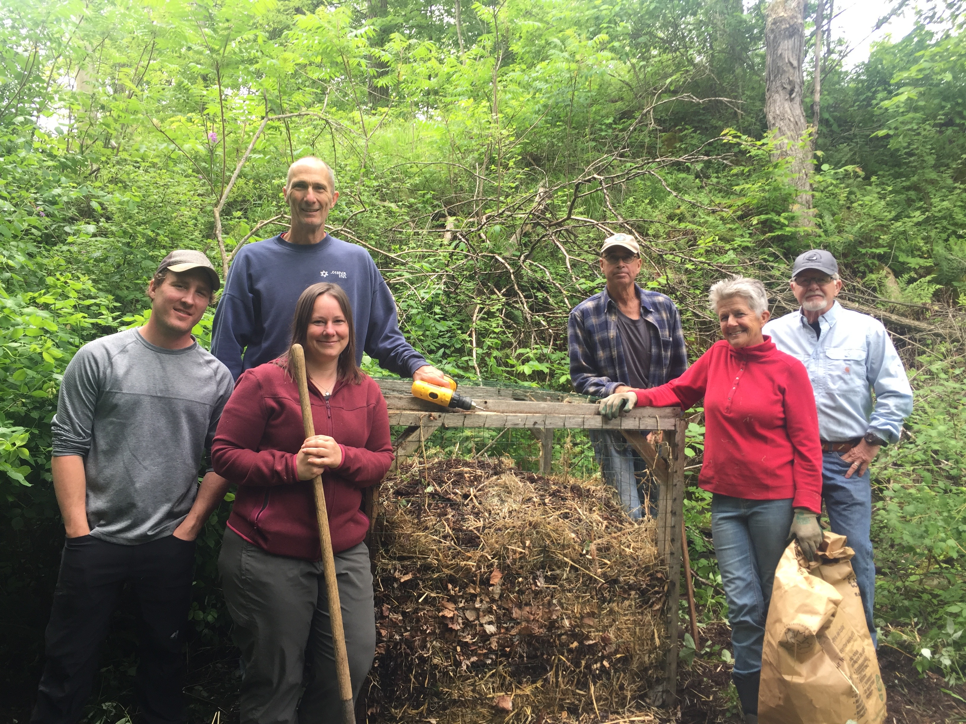

Roundtable on Recovery Efforts for Gray Ratsnakes in the Frontenac Arch

In June of 2017 and 2018 LGSC organized and hosted a roundtable with local organizations interested in, and involved in, efforts to recover the Frontenac Arch population of the Gray Ratsnakes.

Representatives attended:

Murphy’s Point Provincial Park
Charleston Lake Provincial Park

Ontario Ministry of Natural Resources – Kemptville and Kingston offices
Thousand Islands National Park
Thousand Islands Watershed Land Trust
Lanark Stewardship Council
Frontenac Stewardship Foundation
Rideau Valley Conservation Authority

In 2018 discussions focused on current recovery efforts and four areas where work is ongoing:

1. Active Research/Monitoring -
- Research at QUBS – Ministry of Transportation Ontario SAR Overall benefit permit requirement - Matt Macpherson is conducting research (over the next two field seasons) on nest box use, success and effectiveness and mitigation fencing. Matt has 12 nest boxes deployed in a variety of ecosystem conditions (slope, canopy cover etc.) and will deploy temperature probes at three levels in each box. Matt will add temperature probes to the two LGSC nest boxes at QUBS to increase the sample size. He will also test a variety of fencing materials (vinyl, hardware cloth etc.) to determine their effectiveness in blocking GRS passage.
Action - Tobi K. will deploy an additional nest box at Murphy’s Point PP which Matt can add to the sample.

- Monitoring Hibernacula at Thousand Islands NP - Josh and staff are monitoring 5 hibernacula (1 annually) using a barrier/funnel method with remote camera that allows a census of snakes leaving the hibernaculum. There was much interest in the approach and technology.
2. Education and Outreach -
- QUBS - doing outreach at their annual Open House and at Elbow Lake facility.
- Thousand Is National Park - planning outreach over the summer months - first opportunity at Rib Fest Canada Day.
- Murphy’s Point PP - ongoing outreach and education over the summer including with Lake Associations
Action: LGSC to provide copies of the Gray Rat Snake - Landowner Guide to QUBS and Thousand Islands NP for dissemination.

3. Nest Box Program -
- LGSC continuing the nest box program with locations at Langdon Bay, Dr. Ross property, Upper Beverly Lake and QUBS (2)
- Lanark County Stewardship (Emily V.) expressed an interest in extending the program into Lanark County. There was some discussion about the fact that there were boxes built which needs to be verified. LGSC and LCS to discuss further.
- TIWLT - Ed Lowans expressed an interest in nest boxes for Lost Bay - to discuss further.
4. MNR&F SAR Permits for Overall Benefits -
- In addition to the discussion around the MTO sponsored research in item one, there was a good discussion of additional permit (i.e. creation of basking areas) and of a new permit which has been issued for a project just north of Gananoque.

Work will continue over the coming years to further enhance efforts for the recovery of the Frontenac Arch population of the Gray Ratsnake.

Turtles

The United County of Leeds and Grenville is home to many endangered species of turtles. LGSC and South Nation Conservation Authority have installed basking rafts, nesting sites and have fenced road shoulders to create nesting habitats.

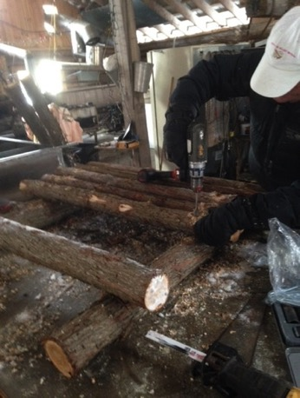

We continue to care for the basking rafts in the creek and the fenced nesting areas on the road shoulders on the Skakum Road and have installed a raft to create basking sites in the Lord’s Mills Quarry, which is home to Blanding’s and Painted turtles.

In 2016 2 rafts were installed – the picture below is deploying a raft into the South Nation River at Stephenson Road.

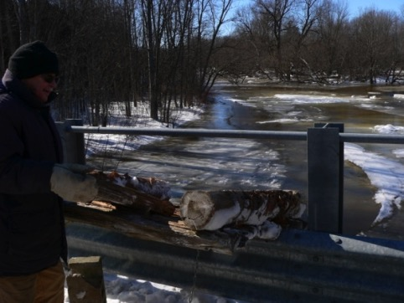

In 2017 two additional rafts were constructed using cedar posts.
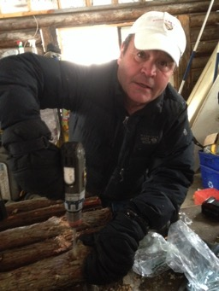
The two rafts were placed in Cooligan Creek (which flows into Lower Beverly Lake) on March 3, 2017.
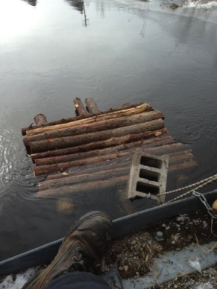

In previous years, working with the South Nation Conservation Authority, a rectangular cedar log crib-nesting site was installed at Stephenson Road. This site was selected due to reports and observations of heavy nest activity on the shoulder of the road. Habitat enhancements are designed to replicate natural turtle nesting areas typically found on roadsides.

EDUCATION AND AWARENESS

LGSC has long been committed to education and awareness campaigns concerning important environmental themes. In 2018 this tradition has continued in a variety of ways and focused on a diversity of themes as well as audiences.

Woodworking for Wildlife

Leeds Grenville Stewardship Council volunteers actively support elementary school teachers through the Woodworking for Wildlife program. It is one of our most popular programs.

The program starts early in the winter as Garnet Baker, Dwayne Struthers and their many helpers convert their supply of Ottawa Valley white pine lumber into hundreds of pre-sawn and drilled bird box kits.

As in other years, in 2018 the construction of box kits started early in the year with 7 volunteers assembling some 200 blue bird box kits
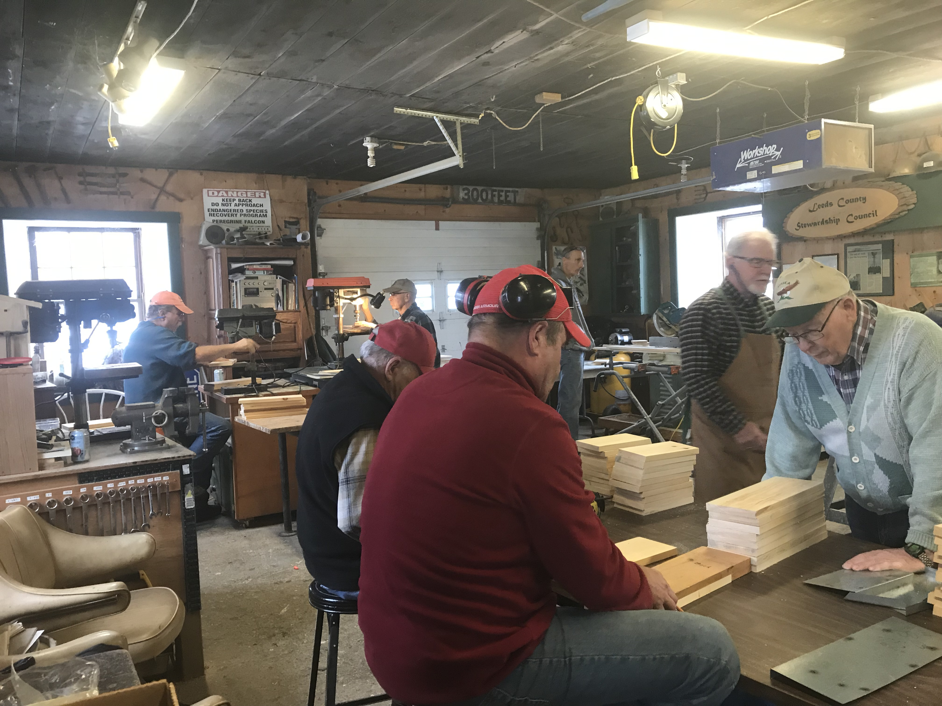

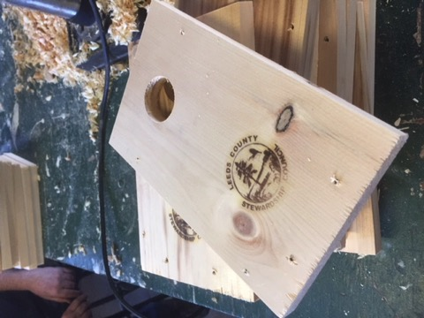

After listening to a short presentation, each child in the class gets the opportunity to construct and take home a blue bird box. Council members and the teacher are always nearby to offer advice, but the children do the work.

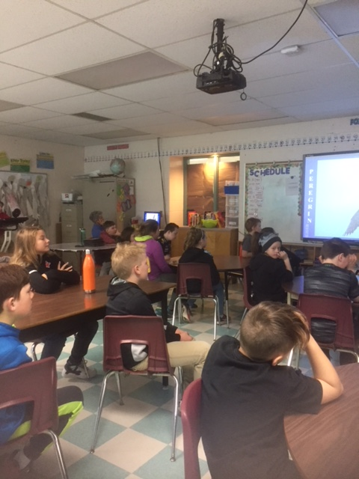
LGSC volunteers visited 5 schools in the United County in 2018 including:
- Pine View Public School - Athens
- Rideau Vista Public School - Westport
- Lombardy Public School – Lombardy
- St. Joseph’s Catholic School – Toledo
- Wolford Public School - Merrickville

In total 107 Grades 3, 4, 5 and 6 students participated and 147 Blue Bird Houses were assembled.

In excess of 85 hours of volunteer time goes into making this program a success.

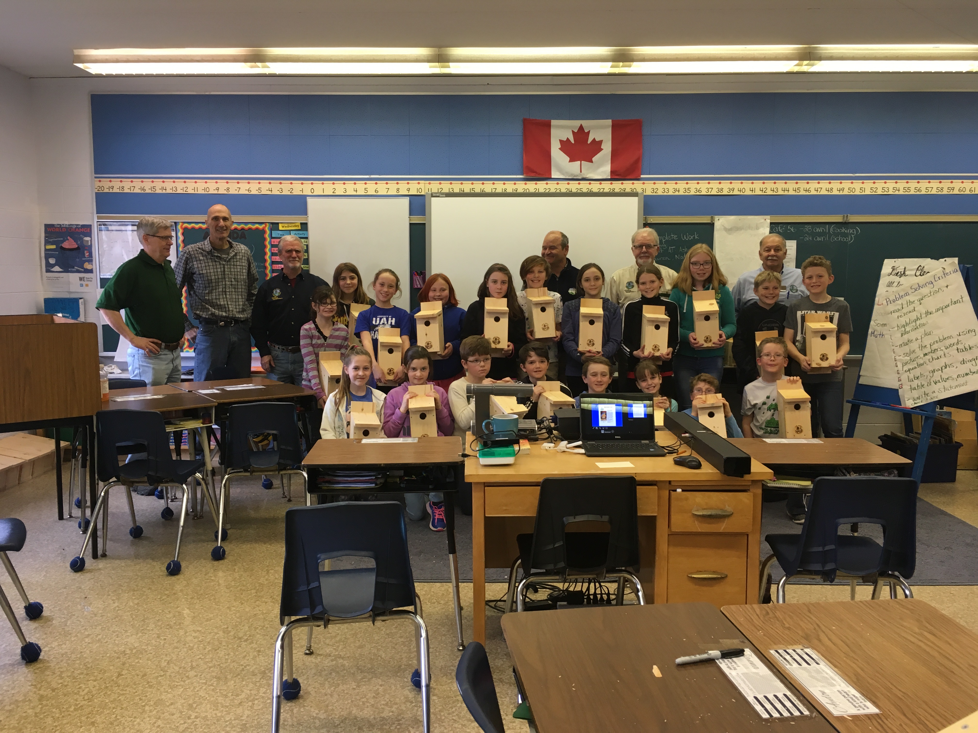

Children’s Water Festival

LGSC is a proud sponsor and contributor to the Children’s Water Festival hosted each year by the St. Lawrence River Institute.

The purpose of the program is to educate young people about the value and fragility of our water resources.

The Festival features approximately 30 hands-on Water Discovery Centers that address five different water related themes – some with catchy names such as Septic Sights, No Water off a Duck’s Back, and Royal Flush.

Within these themes, a variety of other issues are presented such as: groundwater and wells; septic systems; hydropower; contaminants in rivers and lakes; and invasive species. The stations are designed to be hands on, minds on, with an environmental flavor for the elementary students.

The 2018 Spencerville Children’s Water Festival was held on May 10th and 11th. There were some 324 elementary (Grades 3, 4 and 5) on May 10th and 307 on May 11th from schools in Leeds-Grenville attending over the two days. 631 in total split into small groups and accompanied by their teachers and parents.
The volunteers on May 10th were South Grenville District High School and on May 11th Athens District High School. The volunteers run most of stations, explaining to the grade 3's, 4's and 5's the environmental purpose their stations.

In addition to those stations provided by the St Lawrence River Institute, Edwardsburg/Cardinal Public Library, South Nation Conservation Authority, Ontario Power Generation and, for the third time, Leeds Grenville Stewardship Council each had a station.
There were several local donors to the Festival including The Township of Edwardsburg- Cardinal, The Port of Johnstown, Greenfield Ethanol, Leeds Grenville Stewardship, TD Friends, TransCanada and OPG to mention a few.

In addition to a financial donation, LGSC had volunteers on hand during the two days. Dave Robertson and Cliff Rogers have worked hard to perfect the LGSC station. It is a very popular attraction demonstrating transpiration, guaranteed to soak all the participants.

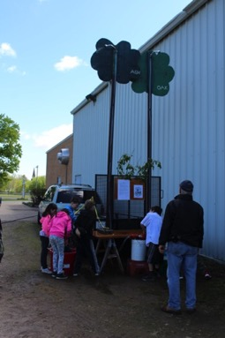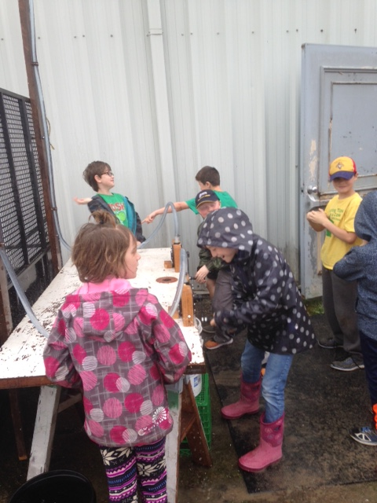

Envirothon 2018 – Limerick Forest

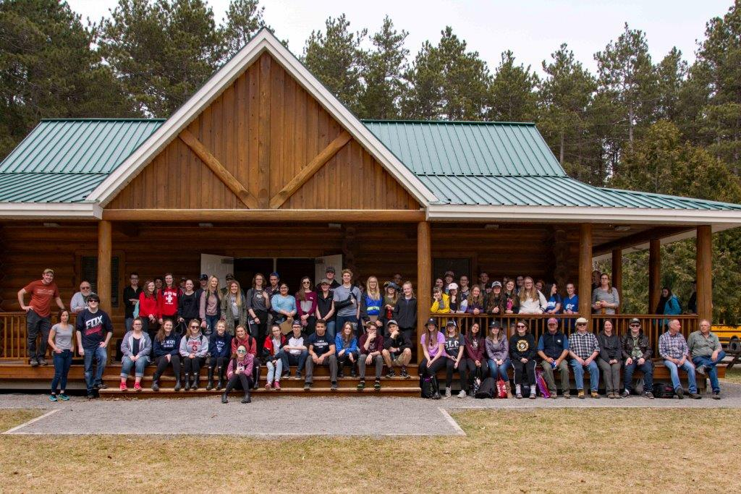

Wetlands –Tree ID – Forest Inventory – Species at Risk

These were the topics presented at this year’s High School Envirothon event held in Limerick Forest April 25, 2018.

13 teams from 5 local high schools participated in this one-day event.
The high schools were:
North Grenville, Prescott
Ange Gabriel, Brockville
St. Mary’s, Brockville
Rideau District Highschool, Elgin
St. Michael’s, Kemptville
Students are bussed out to the Limerick Forest Interpretative Center where there get to explore and learn about the natural environment.

Students are assigned to teams where they compete against other for total points over the day by answering a subject quiz based on the knowledge they learned that day.
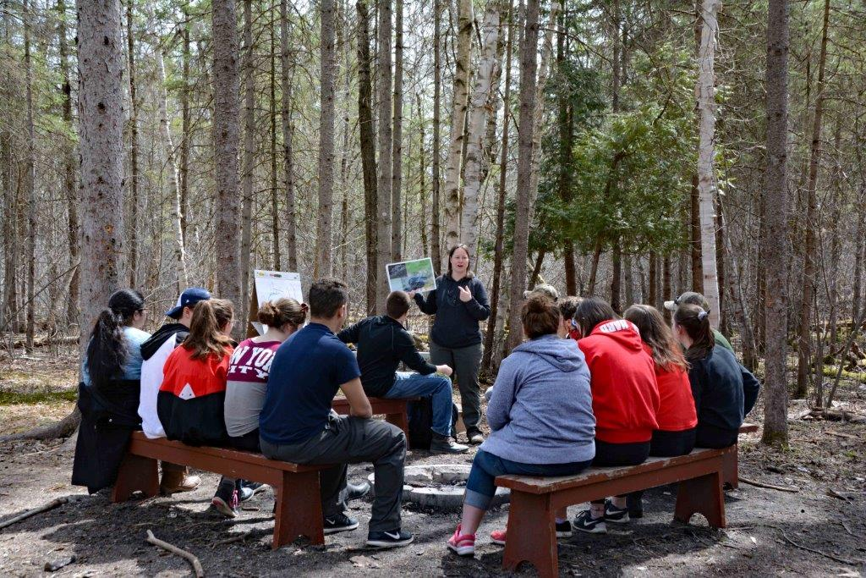

Winning Team

Congratulations to this year's Envirothon winners, Grace Young, Rachel Noonan, Sarah Groves and Taylor Davis from St Mary’s.

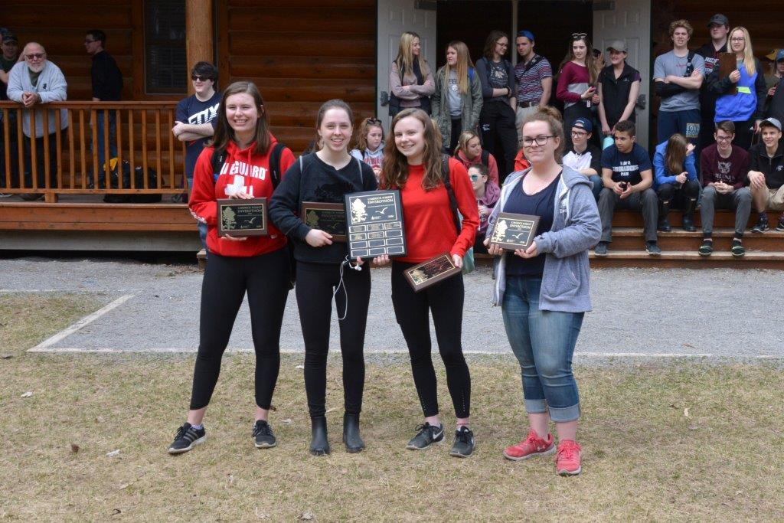

All the teams did well this year and there was a 2-way tie for second place and 3-way tie for third place.

The Envirothon Event is organized and hosted by the United Counties of Leeds and Grenville in partnership with the Leeds and Grenville Stewardship Council.

Thanks to the volunteers for making this event possible and to the teachers for bringing the students. A special thanks to the United Counties of Leeds and Grenville for hosting this event in partnership with the Leeds and Grenville Stewardship Council.

Croskery Woodlot – 2007 - Revisited – 2018
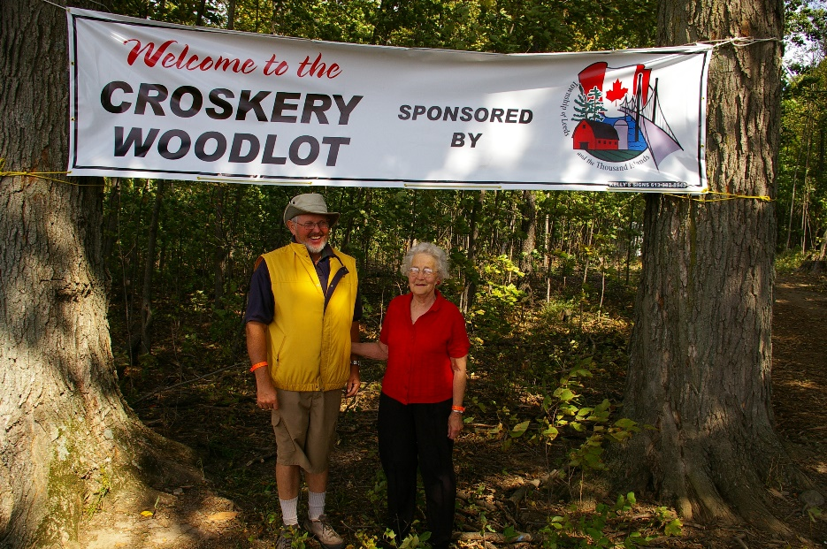
From September 18 to 22, 2007 the rural landscape surrounding the villages of Forfar and Crosby was transformed as over 88,000 people attended the 2007 IPM in Leeds County. The Leeds County Stewardship Council was assigned the task of presenting the managed woodlot and plantation tour at the farm of Rod and Edna Croskery, sponsored by The Township of Leeds and the Thousand Islands.

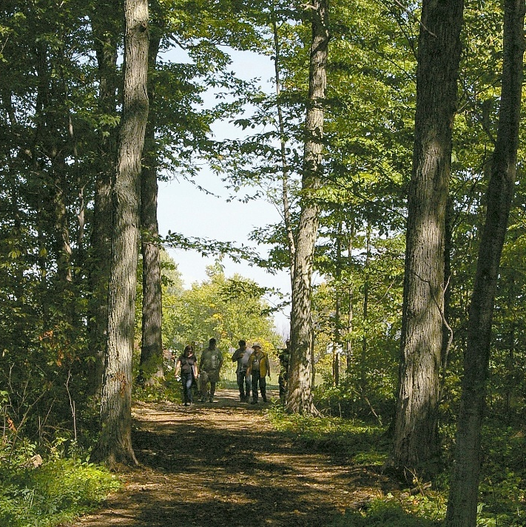
Much of 2007 was spent in preparation for the event. From January through to March, the woodlot was thinned by Ken Carson, a local logger. LCSC hired Upper Canada Forestry Service to mark the trees and oversee the harvest. Assistance was also provided by Brian Anderson, Advisory Services Coordinator at Mississippi Valley Conservation Authority. The quality of the harvest was excellent and the forest is certified and well managed in accordance with the rules of the Forest Stewardship Council (FSC).

In 2018 LGSC arranged a 11 Year Reunion Tour of the Croskery Woodlot.
The woodlot has responded well to the thinning and will be ready for another harvest in a few years. The canopy openings that were created now contain hardwood regeneration including maple, walnut, black cherry, red oak and bitternut hickory. Some of this regeneration was seedlings planted after the harvest that Rod kept free from competition for years.

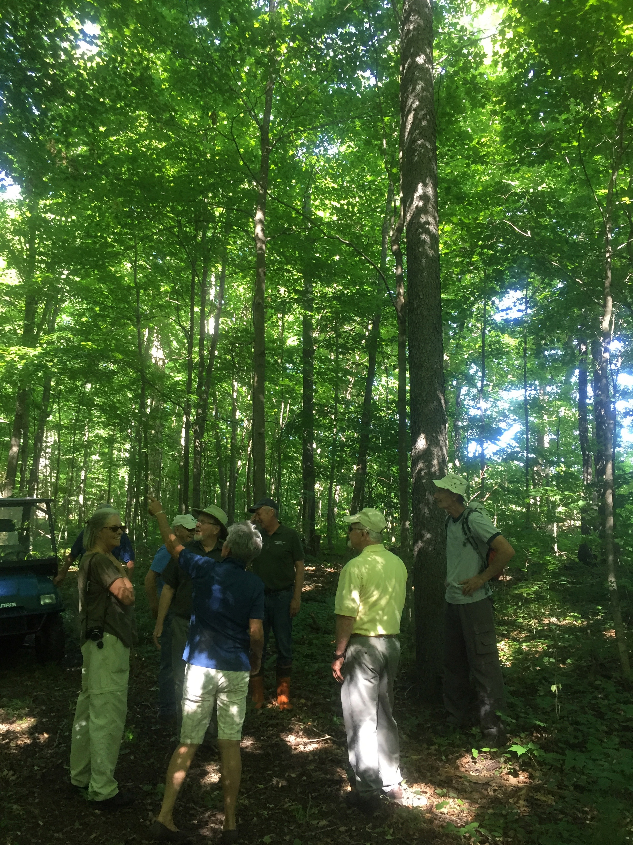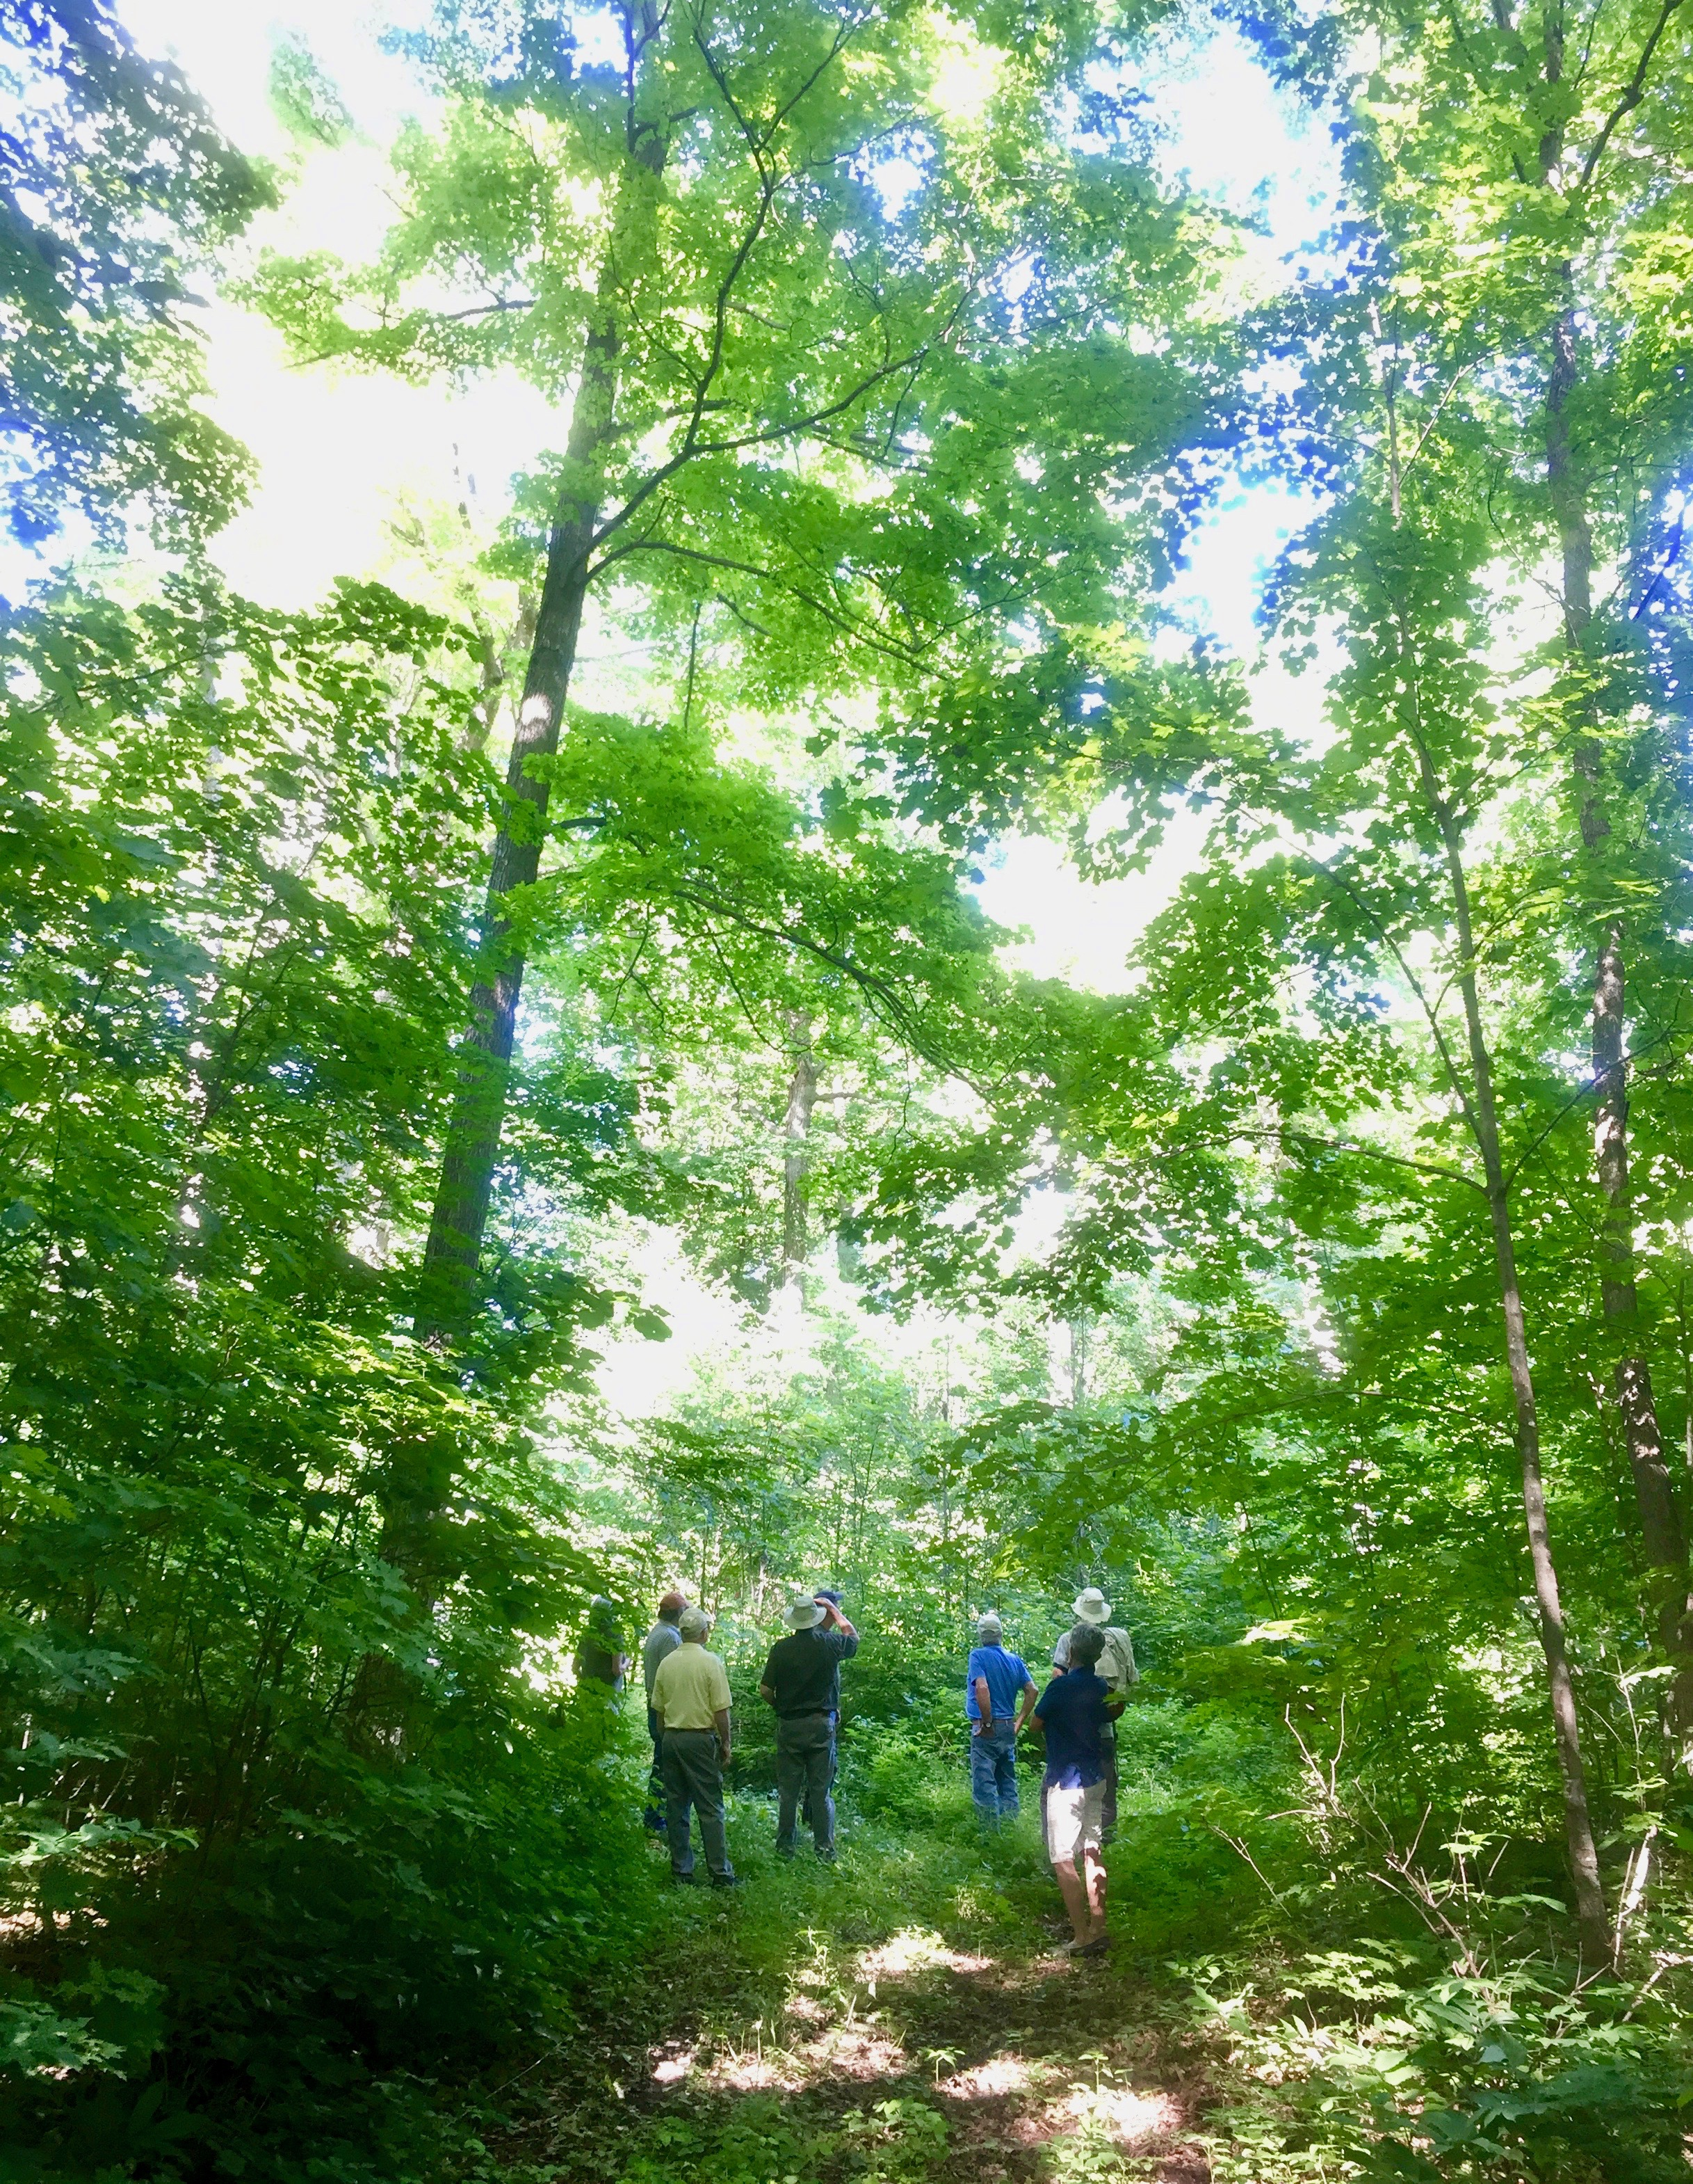

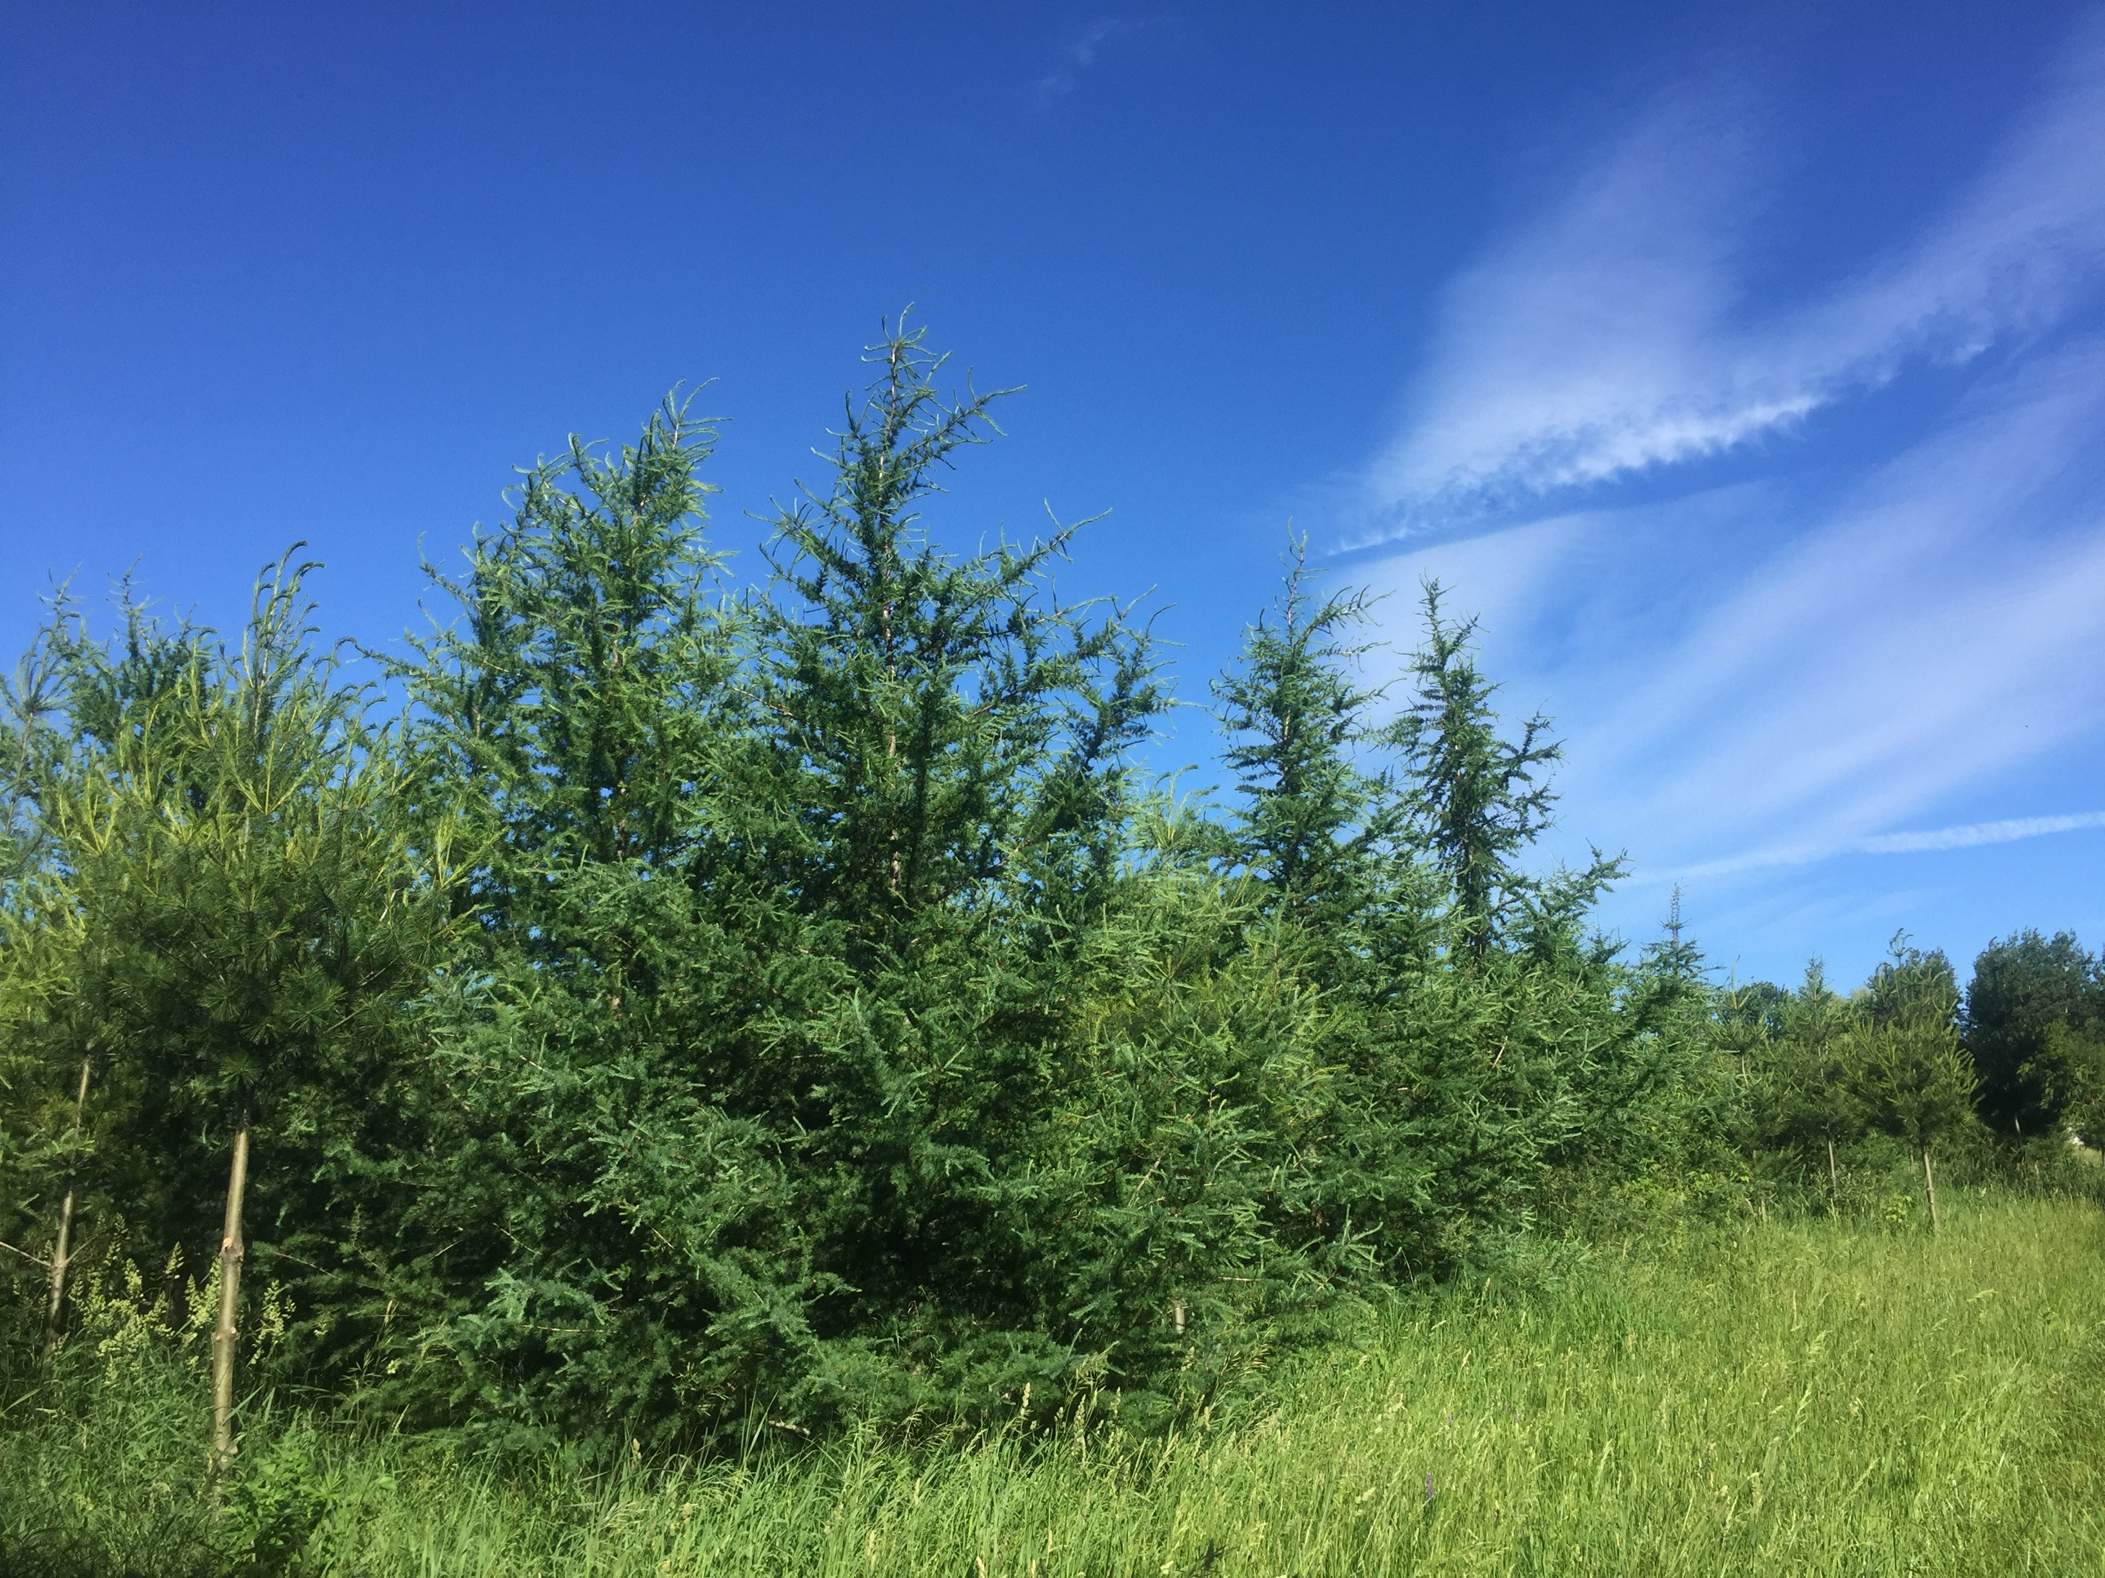

LGSC Student Bursary

The world needs young people to carry forward the torch of stewardship for the earth.

For the last number of years, the Leeds-Grenville Stewardship Council
has made available two (2) $500 bursaries for Leeds and Grenville
students who will be attending Post-secondary education, in the
general field of Environmental Studies.

The award winners are selected by a committee of LGSC members who
chose based on Financial need, Community service, and Academic record.

Applicants had to submit a Resume and Letter describing plans for
post-secondary education and why he or she deserves the bursary.

Because we had many qualified applicants for 2018 we made an exception
and chose 3 excellent candidates:

- Melina Farmer of South Grenville High School;
- Shannon Neville North Grenville High school; and
- Teaghen Clarke of Brockville Collegiate Institute.

Pictured below is Teaghen Clarke.

2018 Youth Summit for Biodiversity and Environmental Leadership

LGSC is proud to be a member of Ontario Nature and to sponsor tomorrow’s environmental leaders to attend the annual youth summit.

In 2018 Laura Maskell and Emma McGurk, both from Eastern Ontario attended the summit courtesy of LGSC sponsorship. See their thank you letters below.

Laura Maskell

Dear Leeds Grenville Stewardship Council,

My name is Laura Maskell, I am 17 years old and I am currently a grade 12 student at North Grenville District High School in Kemptville, Ontario.
I want to say a big thank you for sponsoring me to be a part of the Ontario
Nature Youth Summit for Biodiversity and Environmental Leadership 2018. It was a great way for me to learn tons of new information as well as meet many like-minded people who all have a deep love and care for the environment.

I grew up in a very nature loving household so ever since I was little I’ve been loving and caring about the environment more than most of my fellow peers. It’s because of my deep appreciation, and the lack of it in the other youth around me, that I wanted to go to the youth summit.

The summit this year was my third, and probably final, Youth Summit for Biodiversity and Environmental Leadership. But just like the two before it, I had an amazing time and learned so much. Not only from the amazing
workshops I attended, including shops about Salamander Sleuthing, and looking into being more waste free, but also from the intelligent youth who had so much experience or so many ideas. I made many new friends who I hope to keep in touch with as we all work towards helping save and
protect our planet and environment.

After getting home from the summit I felt very inspired, so I took the knowledge I gained and talked to some of my friends at school. To my surprise, a few of them took to the idea of helping me create some sort of
club at my school where we help the environment and the organisms that live in it. We now have a few different plans, including selling 4Ocean bracelets in our school, which we have already been run by our principal and teacher which will hopefully be coming to action very soon.

Thank you again for your sponsorship,
Laura Maskell

Emma McGurk (in the middle)

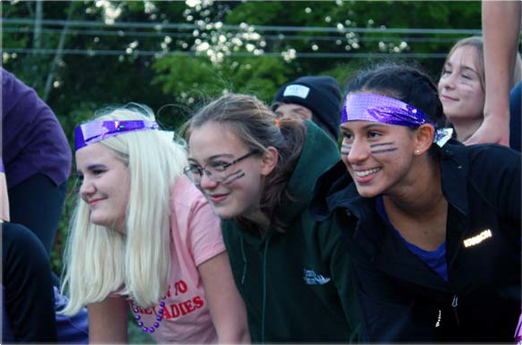

Dear Leeds Grenville Stewardship Council members,

I’d like to thank you for the scholarship you gave me, which allowed me to attend the 2018 Ontario Nature Youth Summit. I am a member of the Ontario Nature Youth Council, which brings together youth from across Ontario to share knowledge and help us develop the confidence needed to be able to create an impact and make change.

I cannot tell you how much this scholarship meant to me, the Youth Summit is something I have been looking forward to since I attended the Youth Council’s retreat in February! This summit brings together not only fellow council members but once again gave me the chance to meet new people. Along with all the amazing and educational workshops I got to partake in. I was able to participate in workshops on climate change, medicinal plants, invasive species, plastic pollution and survival skills. What I especially enjoyed about the Youth Summit was being a part of the planning, being able to see how all the work the youth council did come together at the summit. I loved being able to encourage the summit attendees to join the Youth Council and talk to them about our campaigns and goals. It was also really cool to be able to see all the attendee’s enjoyment of the summit. Our keynote speaker was also amazing! Chloe Dragon Smith was inspirational, her presentation was amazing and informative.

Overall the Youth Summit was amazing! I am extremely grateful to Leeds Grenville Stewardship Council for allowing me this experience!

Yours sincerely, Emma McGurk

OUR COUNCIL

Council Members 2018

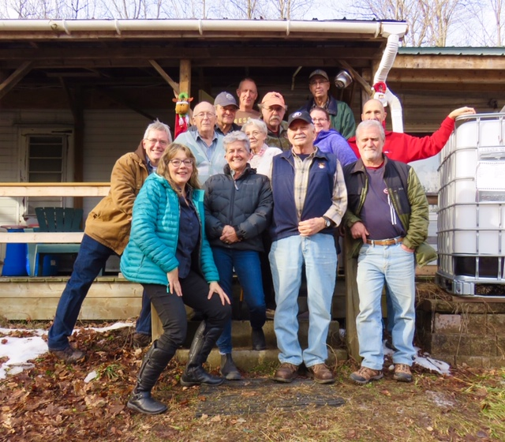

The strength of Leeds Grenville Stewardship Council is the volunteers who work tirelessly to make a difference on the ground. We have a diverse representation including rural and urban residents, landowners, farmers, and retirees from both the provincial and federal governments who live throughout the United Counties of Leeds and Grenville. What the group holds in common is a strong commitment to environmental stewardship.

Garnet Baker Toledo
Karen Brown (Chair) Delta
Rhonda Elliott Chantry
Jack Henry Brockville
Donna O’Connor Elgin
Gary Nielsen Brockville
Laura Parrott Prescott
Dave Robertson (Treasurer) Johnstown
Cliff Rogers Brockville
George Sheffield Chantry
Lloyd Stone Forfar
Dwayne Struthers Toledo
Shaun Thompson Mallorytown

